AUTO SCALING GROUP
- Create one VPC in N. Virginia region.

Objective
To create a Virtual Private Cloud (VPC) in the US East (N. Virginia) – us-east-1 AWS region and establish an isolated network environment for deploying AWS resources such as EC2 instances, load balancers, and databases.

Prerequisites
Before creating the VPC, you should have:
AWS account
- An active AWS account.
- Access to the AWS Management Console.

Step 1: Select N. Virginia
- Log in to the AWS Management Console.
- Look at the Region selector in the top-right corner.
- Select:
US East (N. Virginia) — us-east-1
Make sure you select this before creating the VPC, because VPCs are regional resources.
US East (N. Virginia)
us-east-1

Step 2: Open VPC
Search for:
VPC
Then select VPC from the AWS services.

Step 3: Click Create VPC
From the VPC Dashboard:
Your VPCs → Create VPC
AWS gives you two main choices:
Resources to create

○ VPC only
○ VPC and more
For your task, select:

VPC only
AWS's documentation confirms that VPC only creates the VPC without automatically creating subnets, route tables, gateways, etc.

Step 4: Enter VPC details
You can use these values:
Setting | Value
Resources to create | VPC only
Name tag | My-VPC
IPv4 CIDR block | 10.0.0.0/16
IPv6 CIDR block | No IPv6 CIDR block
Tenancy | Default

Step 5: Create the VPC
Scroll down and click:
Create VPC
AWS will create something similar to:
VPC name: My-VPC
VPC ID: vpc-xxxxxxxxxxxxxxxxx
CIDR: 10.0.0.0/16
Region: us-east-1
AWS describes a VPC as a logically isolated virtual network where you control IP ranges, subnets, routing, and connectivity.

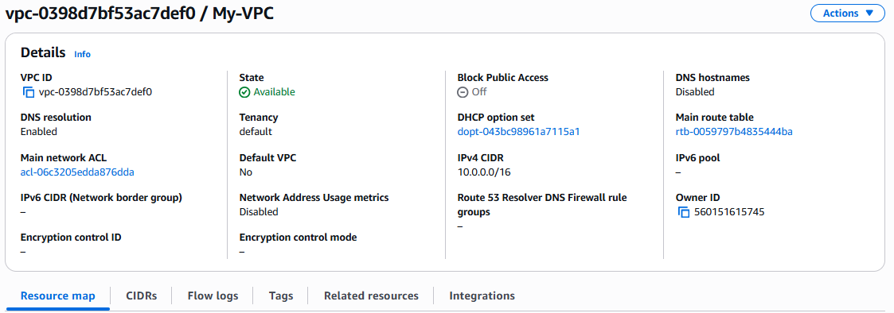

- Create two subnets: one public subnet and one private subnet.

Objective :
The objective of this task is to create a Virtual Private Cloud (VPC) in the AWS N. Virginia region (us-east-1) with a custom IPv4 CIDR block.
After completing this task, you should have:
AWS Region
│
└── US East (N. Virginia)
│
└── VPC
Name: My-VPC
CIDR: 10.0.0.0/16
The VPC will provide an isolated networking environment where you can later create subnets, route tables, Internet Gateway, NAT Gateway, security groups, and EC2 instances.

Prerequisites :
Before creating the VPC, you need:

1. AWS Account
You need an active AWS account with access to the AWS Management Console.

2. IAM Permissions
Your IAM user/role should have permission to create and manage VPC resources, such as:
ec2:CreateVpc
ec2:DescribeVpcs
ec2:ModifyVpcAttribute
ec2:CreateTags
For a practice environment, an appropriate administrative permission set can simplify this.

3. AWS Region
You should know the required region:
Region: US East (N. Virginia)
Region code: us-east-1

4. CIDR Block
For this exercise, we'll use:
10.0.0.0/16
This gives the VPC an address range from:
10.0.0.0
↓
10.0.255.255

Step-by-Step Implementation

Step 1: Log in to AWS
Open the AWS Management Console and sign in.

Step 2: Select N. Virginia Region
At the top-right of the AWS Console, click the Region selector.
Select:
US East (N. Virginia)
us-east-1
Your console should now indicate:
N. Virginia

Step 3: Open the VPC Console
In the AWS Console search bar, search for:
VPC
Select:
VPC — Virtual Private Cloud

Step 4: Go to Your VPCs
From the left-hand navigation menu, select:
Your VPCs
Then click:
Create VPC

Step 5: Select "VPC only"
On the Create VPC page, you may see options such as:
Resources to create

○ VPC only
○ VPC and more
Select:

VPC only
We are selecting VPC only because the objective of this exercise is specifically to create a VPC.
We will create subnets, Internet Gateway, route tables, etc. separately.

Step 6: Configure the VPC
Enter the following values:
Setting | Value
Resources to create | VPC only
Name tag | My-VPC
IPv4 CIDR block | 10.0.0.0/16
IPv6 CIDR block | No IPv6 CIDR block
Tenancy | Default
Your configuration should look like:
Name tag:
My-VPC

IPv4 CIDR:
10.0.0.0/16

IPv6 CIDR:
No IPv6 CIDR block

Tenancy:
Default

Step 7: Understand the CIDR
The CIDR:
10.0.0.0/16
defines the private IP address range available inside your VPC.
Conceptually:
10.0.0.0/16
│
├── 10.0.0.0
├── 10.0.0.1
├── 10.0.0.2
├── ...
└── 10.0.255.255
Later, you can divide this VPC into smaller subnets.
For example:
VPC
10.0.0.0/16
│
├── Public Subnet
│ 10.0.1.0/24
│
└── Private Subnet
10.0.2.0/24

Step 8: Keep Tenancy as Default
Select:
Tenancy: Default
For a normal EC2 environment, Default tenancy is what you generally want.
Dedicated tenancy is used for specific requirements where EC2 instances need dedicated hardware.

Step 9: Create the VPC
Review the configuration:
Name: My-VPC
CIDR: 10.0.0.0/16
Region: us-east-1
Tenancy: Default
Then click:

Create VPC
AWS will create the VPC.

Step 10: Verify the VPC
After creation, go to:
VPC → Your VPCs
You should see something similar to:
Name IPv4 CIDR State
---------------------------------------
My-VPC 10.0.0.0/16 Available
Select the VPC.
Verify:
VPC ID:
vpc-xxxxxxxxxxxxxxxxx

IPv4 CIDR:
10.0.0.0/16

State:
Available

Tenancy:
Default
The actual VPC ID will be different in your account.

Step 11: Verify the Region
Make sure the AWS Console is still showing:
US East (N. Virginia)
and the VPC was created in:
us-east-1

Expected Result
At the end of the task, you should have:
AWS
│
↓
US East (N. Virginia)
us-east-1
│
↓
My-VPC
10.0.0.0/16
│
│
VPC available

Resources created
✅ VPC
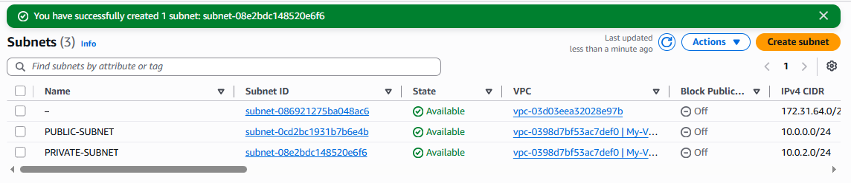

- Attach an IGW to the VPC.

Objective :
The objective is to create an Internet Gateway (IGW) and attach it to the My-VPC so that resources in a properly configured public subnet can communicate with the internet.
Architecture:

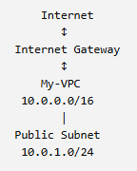
Important: Attaching an IGW alone does not make a subnet public. You also need a route table with a route 0.0.0.0/0 → IGW associated with the public subnet.

Prerequisites
Before starting, make sure:
- AWS account is available
- Region is US East (N. Virginia) — us-east-1
- VPC My-VPC exists
- VPC CIDR is 10.0.0.0/16
- Public subnet has been created

Step 1: Open the VPC Console
Go to the AWS Console.
Search for:
VPC
Open the VPC service.

Step 2: Go to Internet Gateways
In the left navigation menu, find:
Virtual private cloud → Internet gateways
Click:
Internet gateways
You should see the Internet Gateways page.

Step 3: Create an Internet Gateway
Click:
Create internet gateway
Enter the name:
My-IGW
Then click:
Create internet gateway
You should get something similar to:
Name: My-IGW
IGW ID: igw-xxxxxxxxxxxxxxxxx
State: Detached
At this point, the IGW exists, but it is not attached to your VPC.

Step 4: Attach the IGW to the VPC
Select:
My-IGW
Then choose:
Actions → Attach to a VPC
You will see a list of VPCs.
Select:
My-VPC
Then click:
Attach internet gateway

Step 5: Verify the Attachment
Go back to:
VPC → Internet gateways
Select My-IGW.
You should see:
Internet Gateway:
My-IGW

State:
Attached

VPC:
My-VPC
You can also go to:
VPC → Your VPCs → My-VPC
and check the VPC details.
ARCHITECTURE :
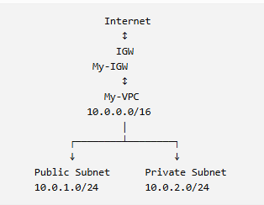
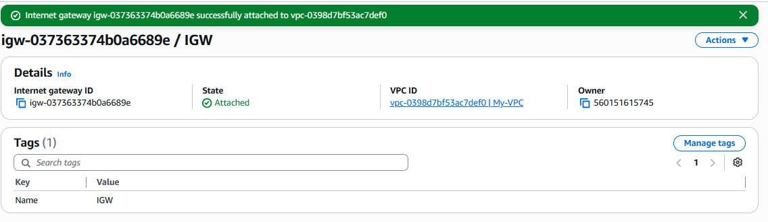

- Create one public route table (RT) and one private route table.

Objective :
The objective is to create two separate route tables inside the My-VPC:
- Public Route Table — will be associated with the public subnet and will later contain a route to the Internet Gateway.
- Private Route Table — will be associated with the private subnet and will not have a direct route to the Internet Gateway
Current architecture
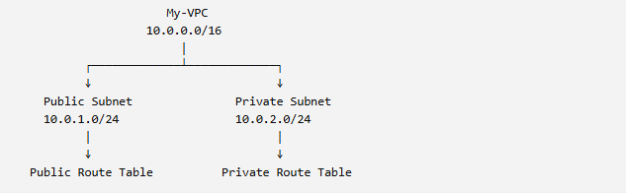

Prerequisites :
Before starting, make sure you have:
- AWS account
- Region: US East (N. Virginia) — us-east-1
- VPC: My-VPC
- VPC CIDR: 10.0.0.0/16
- Public subnet: 10.0.1.0/24
- Private subnet: 10.0.2.0/24
- Internet Gateway: My-IGW, attached to My-VPC
Step by step implementation :

Step 1: Open Route Tables
Go to:
AWS Console → VPC → Route tables
Click:
Create route table

Step 2: Enter Public Route Table Details
Enter:
Name:
Public-RT

VPC:
My-VPC
Your configuration:
Setting | Value
Name | Public route
VPC | My-VPC
Click:
Create route table
You should get something similar to:
Name: Public route
Route Table ID: rtb-0059797b4835444ba
VPC: My-VPC

Part 2: Create the Private Route Table
Again click:
Create route table
Enter:
Name:
Private route

VPC:
My-VPC
Click:
Create route table
You should now have:
Public route
Private route
Both belong to:
My-VPC
10.0.0.0/16

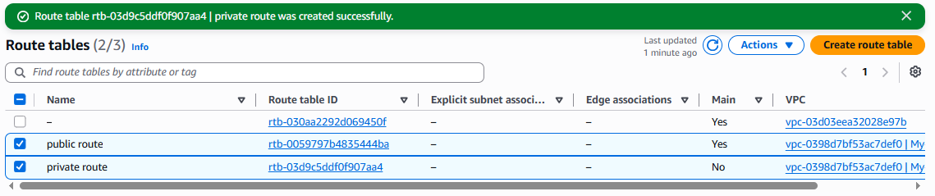

Step 3 : Configure the Public Route Table
Now we need to tell the public route table:
Traffic going outside the VPC should go through the Internet Gateway.
Select:
Public route
Go to:
Routes → Edit routes
You will normally already have:
Destination Target
--------------------------------
10.0.0.0/16 local
This local route allows communication between resources inside the VPC.
Click:
Add route
Enter:
Destination:
0.0.0.0/0
For Target select:
Internet Gateway
Then select:
My-IGW
So the final routes should look like:
Destination Target
--------------------------------
10.0.0.0/16 local
0.0.0.0/0 My-IGW
Click:
Save changes

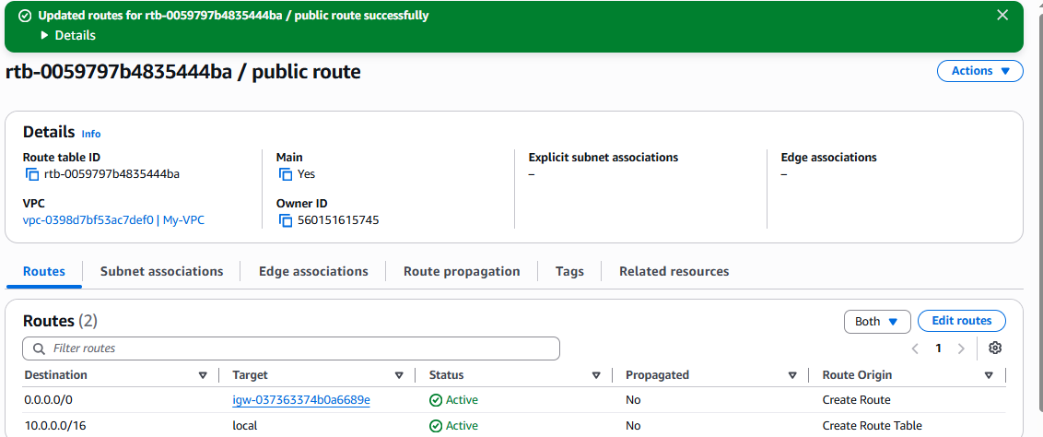

Step 4: Configure the Private Route Table
Select:
Private route
Go to:
Routes → Edit routes
You should have:
Destination Target
--------------------------------
10.0.0.0/16 local
For now, do not add:
0.0.0.0/0 → Internet Gateway
So your private route table remains:
Destination Target
--------------------------------
10.0.0.0/16 local
This means the private subnet does not have a direct route to the Internet Gateway.
Later, if private instances need outbound internet access, you can add a route such as 0.0.0.0/0 → NAT Gateway.
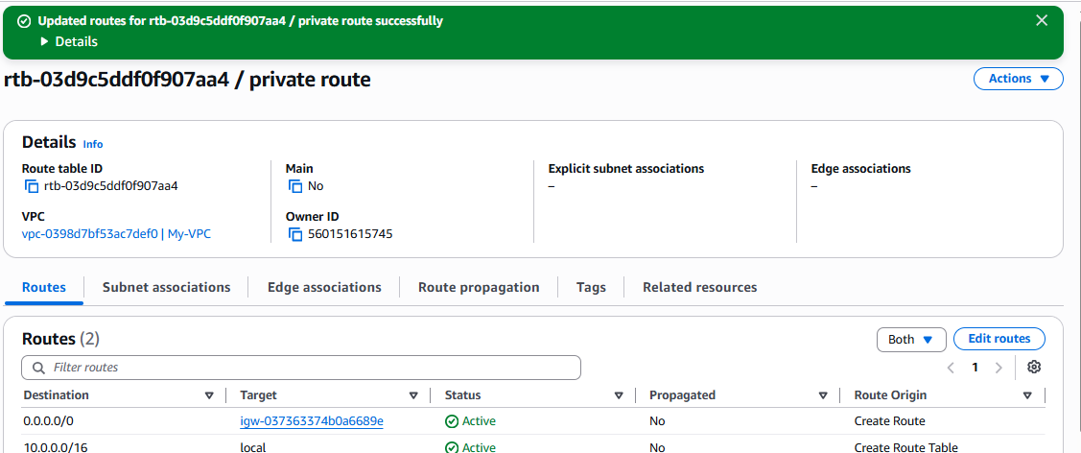

Part 6: Associate Private-RT with Private Subnet
Select:
Private route
Go to:
Subnet associations → Edit subnet associations
Select:
☑ Private-Subnet
Which is:
10.0.2.0/24
Click:
Save associations
Now:
Private-Subnet
↓
Private route

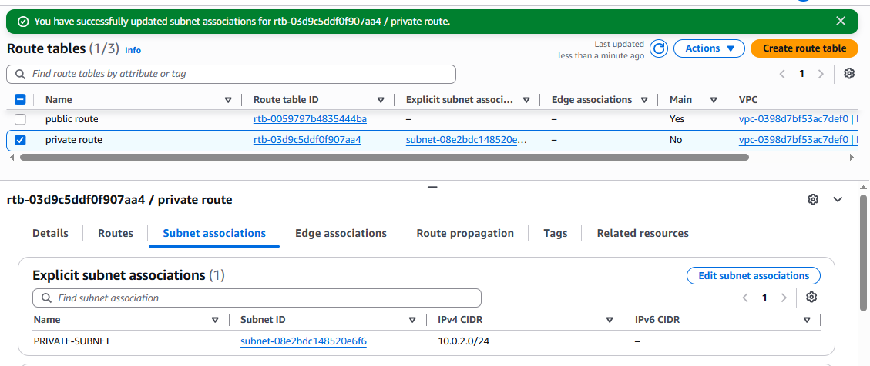

5. Deploy a NAT gateway in the public subnet and attach the NAT gateway to the private subnet.

Objective
The objective is to create a NAT Gateway in the public subnet so that resources in the private subnet can access the internet for outbound connections, while remaining unreachable directly from the internet.

Architecture :

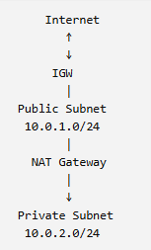

Prerequisites
You should already have:
- VPC: My-VPC
- VPC CIDR: 10.0.0.0/16
- Public subnet: Public-Subnet — 10.0.1.0/24
- Private subnet: Private-Subnet — 10.0.2.0/24
- Internet Gateway: My-IGW
- Public route table: Public-RT
- Private route table: Private-RT
- Public route: 0.0.0.0/0 → My-IGW

Step 1: Open NAT Gateways
Go to:
AWS Console → VPC → NAT gateways
Click:
Create NAT gateway
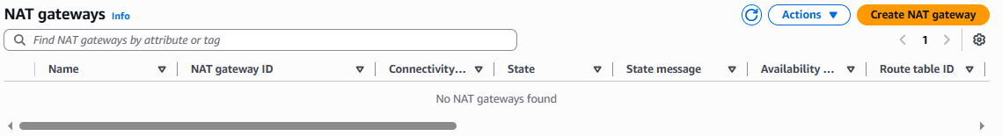

Step 2: Configure NAT Gateway
You'll see fields such as:

Name
Enter:
My-NAT-Gateway

Subnet
Select:
Public-Subnet
Which is:
10.0.1.0/24

Connectivity type
Select:
Public
A public NAT Gateway requires an Elastic IP address.

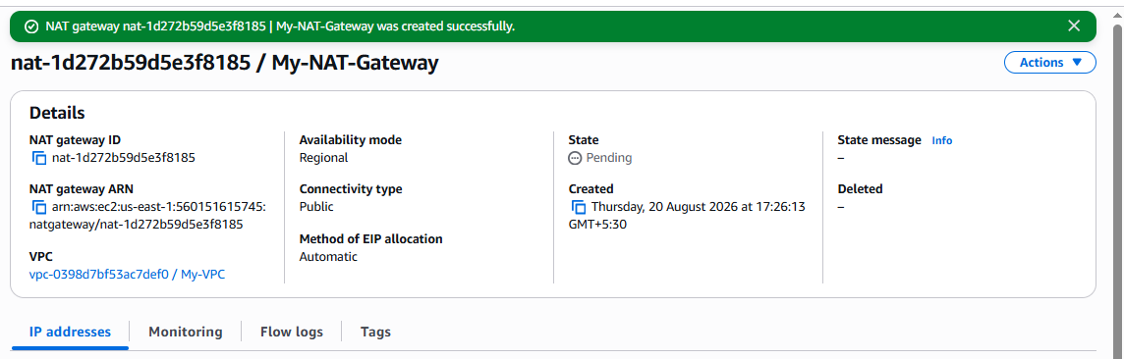

Step 4: Create the NAT Gateway
Your configuration should look approximately like:
Name:
My-NAT-Gateway

Subnet:
Public-Subnet

Connectivity type:
Public

Elastic IP:
54.xxx.xxx.xxx
Click:
Create NAT gateway
The initial status will normally be:
Pending
Wait until the status becomes:
Available
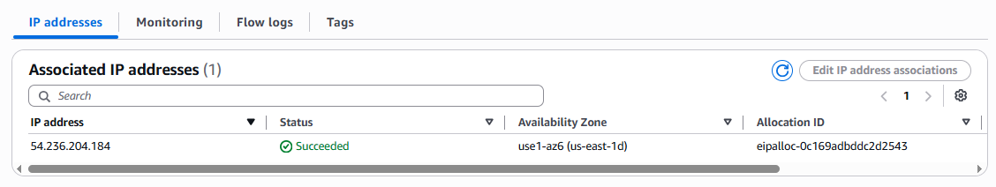

Step 5: Verify NAT Gateway
Go to:
VPC → NAT gateways
You should see:
Name: My-NAT-Gateway
State: Available
Subnet: Public-Subnet
VPC: My-VPC
Elastic IP: 54.xxx.xxx.xxx
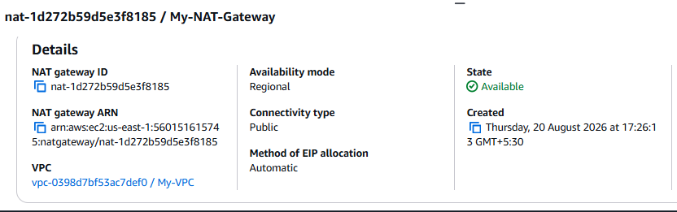

Step 6: Configure the Private Route Table
This is the most important step.
Go to:
VPC → Route tables
Select:
Private route
Then:
Routes → Edit routes
You should currently have:
Destination Target
--------------------------------
10.0.0.0/16 local
Click:
Add route
Enter:
Destination:
0.0.0.0/0
For Target select:
NAT Gateway
Then select:
My-NAT-Gateway
Your private route table should now look like:
Destination Target
--------------------------------
10.0.0.0/16 local
0.0.0.0/0 My-NAT-Gateway
Click:
Save changes
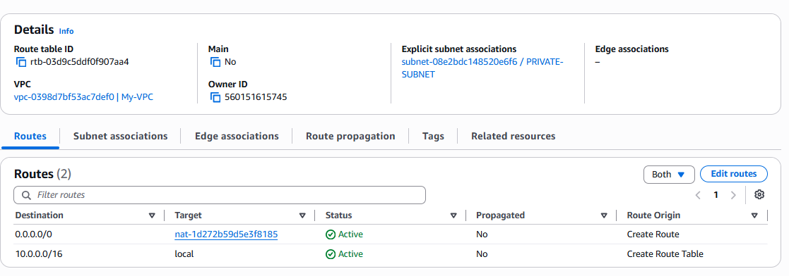

Step 7: Verify Private Subnet Association
Make sure:
Private-Subnet
↓
Private-RT
↓
0.0.0.0/0
↓
NAT Gateway
The NAT Gateway itself is located in:
Public-Subnet

Final Architecture
Your complete setup now looks like:
Internet
↑
↓
Internet Gateway
|
┌────────────┴────────────┐
| |
↓ |
Public Subnet |
10.0.1.0/24 |
| |
NAT Gateway |
| |
└──────────────┐ |
↓ |
Private Subnet
10.0.2.0/24
|
Private-RT
|
0.0.0.0/0
|
NAT Gateway
The actual traffic flow from a private EC2 instance is:
Private EC2
↓
Private Subnet
↓
Private Route Table
↓
NAT Gateway
↓
Public Subnet
↓
Internet Gateway
↓
Internet

Why do we need the NAT Gateway?
Suppose an EC2 instance is in the private subnet and needs to download a package:
Private EC2
↓
NAT
↓
Internet
The private EC2 can initiate outbound connections to the internet.
But the internet cannot directly initiate a connection to that private EC2 through the NAT Gateway.
That's the main purpose of NAT Gateway in this architecture.

Final Configuration Checklist

Public subnet
Public-Subnet
10.0.1.0/24
↓
Public-RT
↓
0.0.0.0/0 → IGW
↓
Internet

NAT Gateway
My-NAT-Gateway
↓
Public-Subnet
↓
Elastic IP

Private subnet
Private-Subnet
10.0.2.0/24
↓
Private-RT
↓
0.0.0.0/0 → NAT Gateway
One important correction to the wording of the task: NAT Gateway is deployed in the public subnet, while the private route table is configured to use the NAT Gateway. You don't directly attach the NAT Gateway to the private subnet.
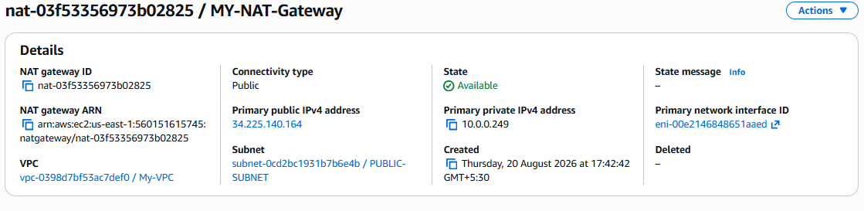

6. Create two instances, one in the public subnet and one in the private subnet.

Objective :
The objective is to launch two EC2 instances inside the VPC:
- Public EC2 → launched in the Public Subnet
- Private EC2 → launched in the Private Subnet
Architecture :
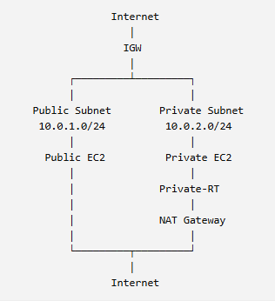

Prerequisites :
Before launching the instances, make sure you have:
- VPC: My-VPC
- VPC CIDR: 10.0.0.0/16
- Public Subnet: Public-Subnet — 10.0.1.0/24
- Private Subnet: Private-Subnet — 10.0.2.0/24
- Internet Gateway attached to My-VPC
- Public Route Table associated with Public-Subnet
- Private Route Table associated with Private-Subnet
- NAT Gateway created in Public-Subnet
- Private route table has:
0.0.0.0/0 → NAT Gateway

Part 1: Create the Public EC2 Instance

Step 1: Open EC2
Go to:
AWS Console → EC2
Click:
Instances → Launch instances

Step 2: Give the Instance a Name
Under Name and tags, enter:
Public-EC2

Step 3: Select an AMI
Under Application and OS Images, select:
Amazon Linux 2023
For example:
Amazon Linux 2023 AMI

Step 4: Select Instance Type
For practice, you can select:
t3.micro
If your account's Free Tier eligibility differs, check the current pricing/eligibility shown in your console before launching.

Step 5: Select/Create Key Pair
Under Key pair, select an existing key pair or click:
Create new key pair
For example:
Name: my-key
Type: RSA
Format: .pem
Download the .pem file and keep it secure.

Step 6: Configure Network
This is the most important part.
Under Network settings, click Edit.
Select:
VPC:
My-VPC
Then:
Subnet:
Public-Subnet
Which is:
10.0.1.0/24
For Auto-assign Public IP, select:
Enable
This allows the EC2 instance to receive a public IPv4 address.

Step 7: Configure Security Group
Create a new security group, for example:
Security group name:
Public-EC2-SG
For SSH:
Type: SSH
Port: 22
Source: My IP
Using My IP is safer for SSH practice than allowing 0.0.0.0/0.
If you want to test a web server, you can additionally allow:
HTTP
TCP
80
Source: 0.0.0.0/0

Step 8: Launch Public EC2
Review the configuration:
Name: Public-EC2
AMI: Amazon Linux 2023
VPC: My-VPC
Subnet: Public-Subnet
Public IP: Enabled
Security Group: Public-EC2-SG
Click:
Launch instance
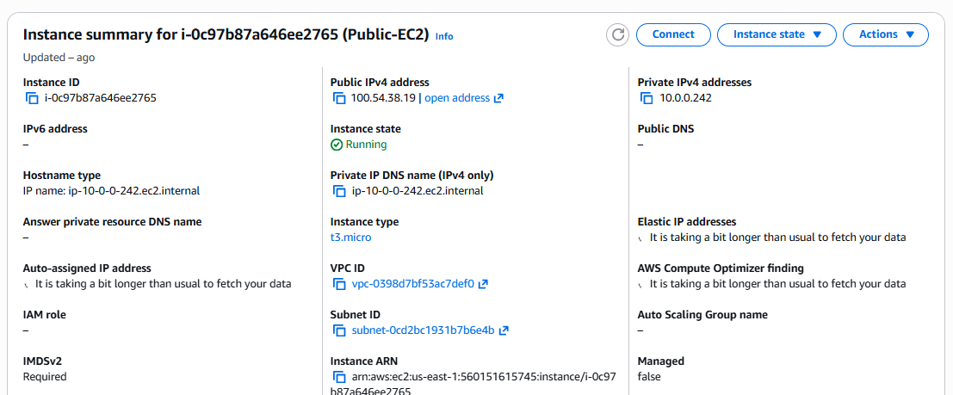

Part 2: Create the Private EC2 Instance
Now create the second instance.
Go back to:
EC2 → Instances → Launch instances

Step 1: Name
Enter:
Private-EC2

Step 2: Select AMI
Select the same:
Amazon Linux 2023

Step 3: Select Instance Type
For practice:
t3.micro

Step 4: Select Key Pair
You can use the same key pair:
my-key

Step 5: Configure Network
Click:
Edit
Select:
VPC:
My-VPC
Then:
Subnet:
Private-Subnet
Which is:
10.0.2.0/24

Auto-assign Public IP
Select:
Disable
This is important.
The private EC2 should not have a public IPv4 address.

Step 6: Security Group
Create:
Private-EC2-SG
For now, you can allow SSH only from the Public EC2's security group rather than from the internet.
For example:
Type: SSH
Port: 22
Source: Public-EC2-SG
This allows:
Public EC2
↓
SSH :22
↓
Private EC2
without exposing SSH on the private instance to the internet.

Step 7: Launch Private EC2
Review:
Name: Private-EC2
AMI: Amazon Linux 2023
VPC: My-VPC
Subnet: Private-Subnet
Public IP: Disabled
Security Group: Private-EC2-SG
Click:
Launch instance

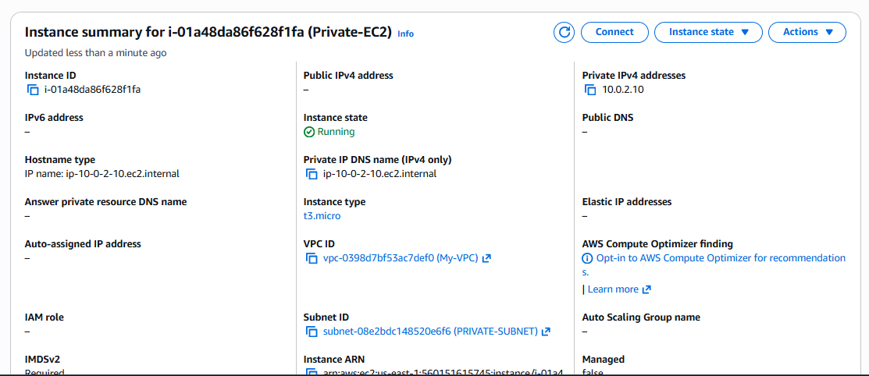

7. Deploy Apache server on both EC2 instances with a sample index.html file.

Objective :
The objective is to install and run an Apache HTTP web server on both EC2 instances and create a different index.html file on each server so we can verify that both servers are working.
We have:
Public-EC2 → Public-Subnet
Private-EC2 → Private-Subnet
We will deploy:
Public-EC2
↓
Apache
↓
index.html → "Hello from Public EC2"

Private-EC2
↓
Apache
↓
index.html → "Hello from Private EC2"

Prerequisites
Make sure:
- Both EC2 instances are running.
- Public EC2 has a public IP.
- Private EC2 has no public IP.
- Public EC2 security group allows SSH (22) from your IP.
- Public EC2 security group allows HTTP (80) if you want to access Apache from your browser.
- Private EC2 security group allows SSH (22) from the Public EC2 security group.
- Private subnet has:
0.0.0.0/0 → NAT Gateway

Part 1: Install Apache on Public EC2

Step 1: Connect to Public EC2
From your local computer, connect using SSH:
ssh -i my-key.pem ec2-user@<PUBLIC-IP>
Replace:
<PUBLIC-IP>
with the public IPv4 address of your Public EC2.

Step 2: Update Packages
Run:
sudo dnf update -y
Amazon Linux 2023 uses dnf as its package manager.

Step 3: Install Apache
Run:
sudo dnf install httpd -y
Apache's service name is:
httpd

Step 4: Start Apache
Run:
sudo systemctl start httpd

Step 5: Enable Apache at Boot
Run:
sudo systemctl enable httpd
This means Apache will automatically start when the EC2 instance is rebooted.

Step 6: Check Apache Status
Run:
sudo systemctl status httpd
You should see:
Active: active (running)
You can also verify with:
curl http://localhost

Step 7: Create index.html
The default Apache document root on Amazon Linux is:
/var/www/html
Create the file:
sudo vi /var/www/html/index.html
Put:
<!DOCTYPE html>
<html>
<head>
<title>Public EC2</title>
</head>
<body>
<h1>Hello from Public EC2</h1>
<p>Apache Web Server is running successfully.</p>
</body>
</html>
Save the file.

Step 8: Test Apache
Run:
curl http://localhost
You should see the HTML content.
Then from your browser:
http://<PUBLIC-IP>
You should see:
Hello from Public EC2

Apache Web Server is running successfully.

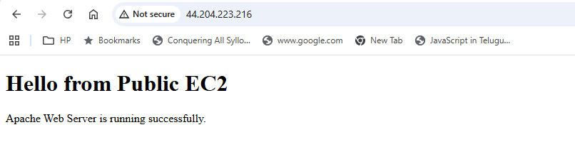

Part 2: Connect to Private EC2
The private EC2 has no public IP, so you cannot normally SSH directly to it from your laptop over the internet.
Instead, use the Public EC2 as a bastion/jump host.

The traffic path is :
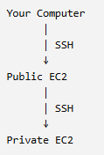

Step 1: Get the Private EC2 Private IP
Go to:
AWS Console → EC2 → Instances → Private-EC2
Copy its:
Private IPv4 address
10.0.2.10

Step 2: SSH from Public EC2 to Private EC2
From the Public EC2:
ssh -i ~/my-key.pem ec2-user@<PRIVATE-IP>
For example:
ssh -i ~/my-key.pem ec2-user@10.0.2.25
You should now be logged into:
Private-EC2
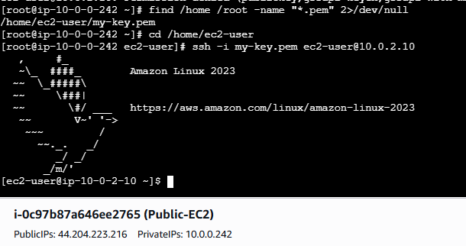

Part 3: Install Apache on Private EC2

Step 1: Update Packages
sudo dnf update -y

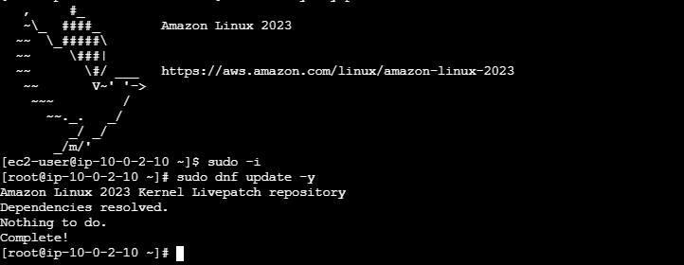

Step 2: Install Apache
sudo dnf install httpd -y

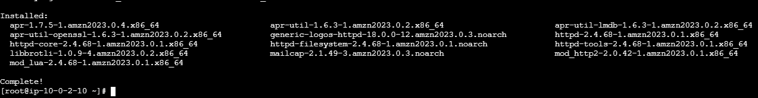

Step 3: Start Apache
sudo systemctl start httpd

Step 4: Enable Apache
sudo systemctl enable httpd

It configures Apache to automatically start during the next system boot.
Now Apache is configured to start automatically after a reboot.
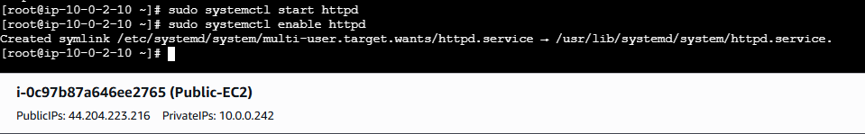

Step 5: Verify Apache
sudo systemctl status httpd
You should see:
Active: active (running)

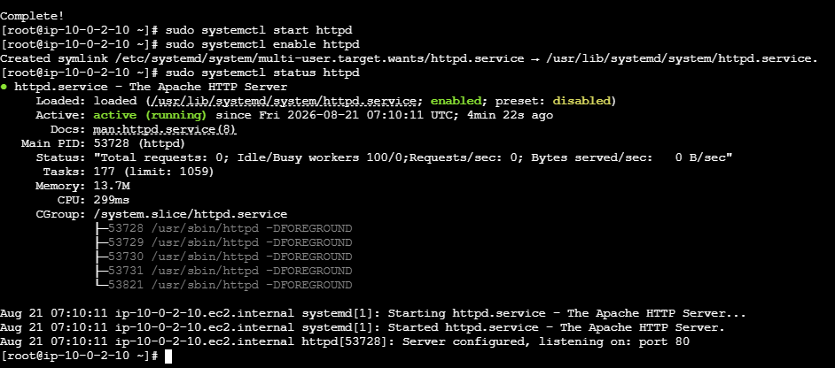

Step 6: Create Private EC2 index.html
Run:
sudo vi /var/www/html/index.html

<!DOCTYPE html>
<html>
<head>
<title>Private EC2</title>
</head>
<body>
<h1>Hello from Private EC2</h1>
<p>Apache Web Server is running successfully.</p>
</body>
</html>
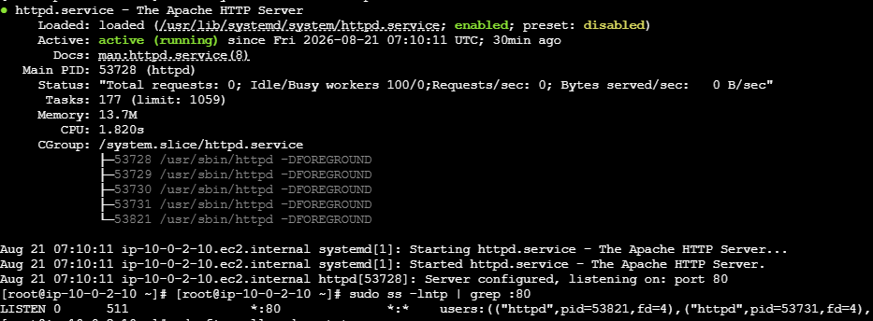
8. Create one application load balancer and attach it to both EC2 instances.

Objective :
The objective is to create an AWS Application Load Balancer (ALB) and configure it to distribute HTTP traffic to both:
Public-EC2
Private-EC2
The ALB will use a Target Group containing both EC2 instances.
Important: You don't directly "attach" EC2 instances to an ALB. The correct architecture is:
ALB → Listener → Target Group → EC2 instances
TARGET ARCHITECTURE
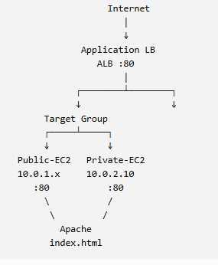

Important networking point
An ALB must have network connectivity to its targets. Since your two instances are in different subnets, that's fine as long as the subnets are in the same VPC and the ALB is configured appropriately.
For a typical internet-facing ALB, put it in two subnets in different Availability Zones. Your current public/private subnet arrangement can work for a lab, but for high availability you would normally use multiple AZs and dedicated public subnets for the ALB.

Prerequisites
Make sure:
- My-VPC exists
- Public-EC2 is running
- Private-EC2 is running
- Apache is running on both
- Apache listens on port 80
- Public-EC2 and Private-EC2 are in the same VPC
- Private EC2 security group allows HTTP from the ALB security group
- Public EC2 security group allows HTTP from the ALB security group

Step 1: Create a Security Group for the ALB
Go to:
EC2 → Security Groups → Create security group
Enter:
Security group name:
ALB-SG

Description:
Security group for Application Load Balancer

VPC:
My-VPC

Inbound rule
Add:
Type: HTTP
Protocol: TCP
Port: 80
Source: 0.0.0.0/0

This allows users on the internet to access the ALB.
Click:
Create security group
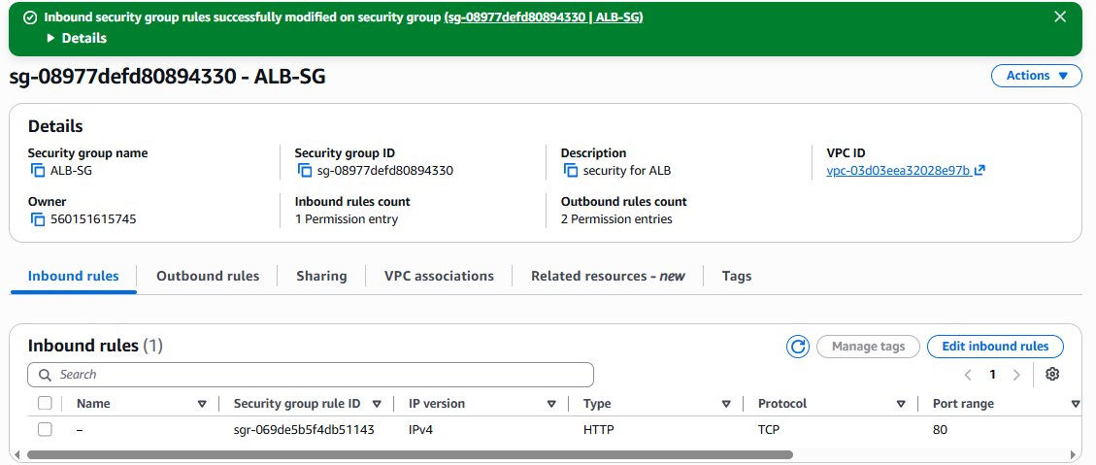

Step 2: Modify the EC2 Security Groups
This is very important.
The EC2 instances should allow HTTP from the ALB, not from everyone.

Public EC2 security group
Go to:
EC2 → Security Groups → Public-EC2-SG → Inbound rules
Add:
Type: HTTP
Port: 80
Source: ALB-SG

Private EC2 security group
Go to:
Private-EC2-SG → Inbound rules
Add:
Type: HTTP
Port: 80
Source: ALB-SG
Now:
Internet
|
↓
ALB-SG
|
↓
Port 80
|
├──→ Public-EC2-SG
|
└──→ Private-EC2-SG

Step 3: Create a Target Group
Go to:
EC2 → Target Groups
Click:
Create target group
EC2 → Target Groups

Step 4: Choose Target Type
Select:
Target type:
Instances
Click Next.

Step 5: Configure Target Group
Enter:
Target group name:
My-Target-Group

Protocol:
HTTP

Port:
80

VPC:
My-VPC

Health check
Use:
Health check protocol:
HTTP

Health check path:
/index.html
This means ALB will periodically request:
GET /index.html
from each EC2.
If the server returns a successful response, the target becomes healthy.

Step 6: Register Both EC2 Instances
On the Register targets page, you should see your instances.
Select:
☑ Public-EC2
☑ Private-EC2
Set port:
80
Then click:
Include as p

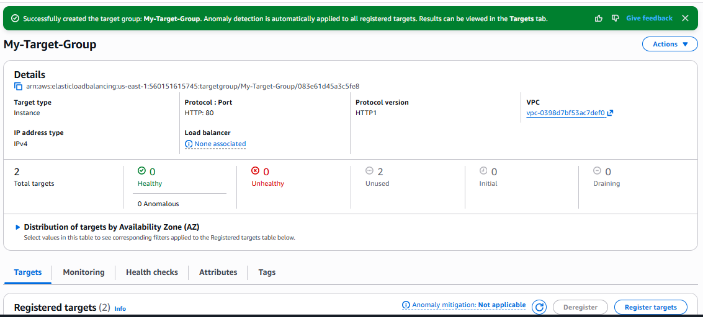

Step 7: Verify Target Health
Go to:
EC2 → Target Groups → My-Target-Group → Targets
You should eventually see:
Target Port Health
-----------------------------------------
Public-EC2 80 Healthy
Private-EC2 80 Healthy

If you see Unhealthy
Check:
1. Apache is running
2. Apache listens on port 80
3. /index.html exists
4. EC2 security group allows port 80 from ALB-SG
5. Network ACL allows the traffic

Step 8: Create the Application Load Balancer
Go to:
EC2 → Load Balancers
Click:
Create Load Balancer
Select:

Application Load Balancer
Click:
Create

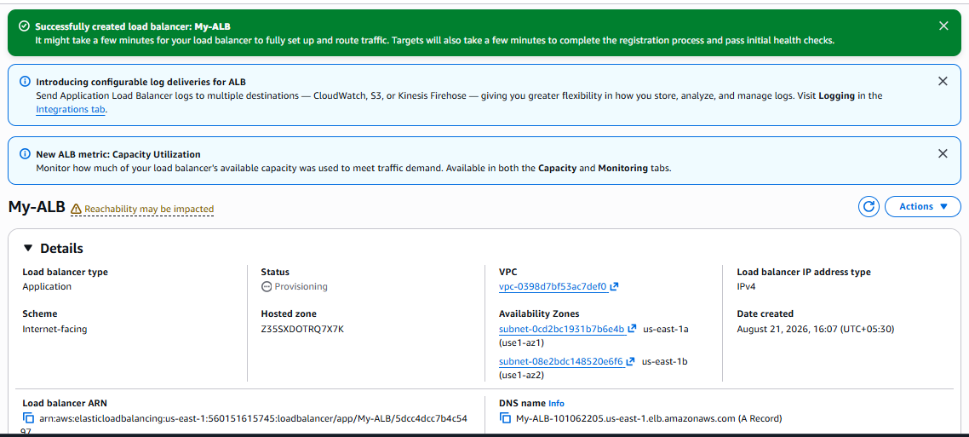
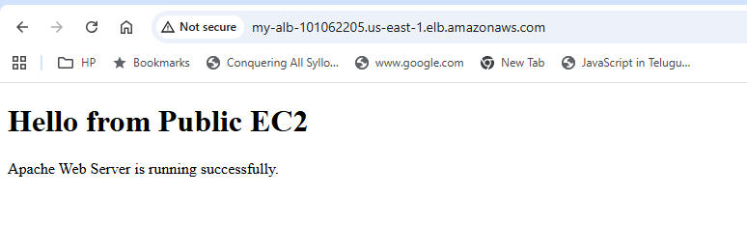
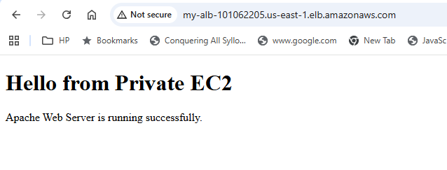

9. Store application load balancer logs in S3.

Objective :
The objective is to enable access logging for your Application Load Balancer (ALB) and store the logs in an Amazon S3 bucket.
The architecture will be:
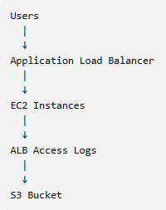
ALB access logs contain information about requests received by the load balancer, such as request time, client information, target information, processing time, response status, and related details.

Prerequisites :
Make sure you have:
- An Application Load Balancer already created.
- An S3 bucket.
- Permission to configure ALB attributes and S3 bucket policies.
- ALB and S3 bucket configured in the appropriate AWS environment.

Step 1: Create an S3 Bucket
Go to:
AWS Console → S3
Click:
Create bucket

Step 2: Enter Bucket Name
Bucket name :

my-alb-logs-bucket-alb
Choose the AWS Region appropriate for your ALB.
For this lab, if your ALB is in N. Virginia:
US East (N. Virginia)
us-east-1
Keep the other settings at their appropriate defaults unless your lab requires something different.
Click:
Create bucket
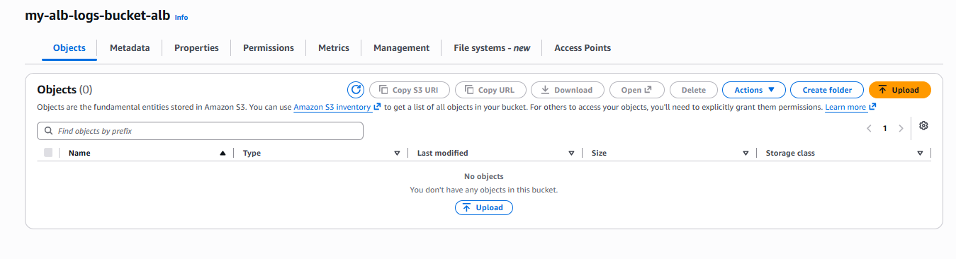
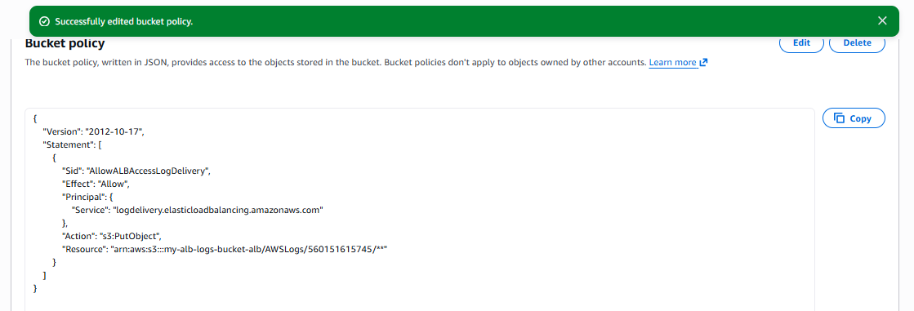

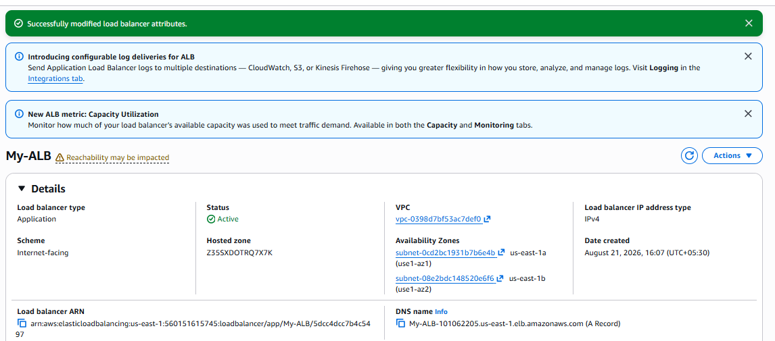

Step 3: Open Your ALB
ALB starts writing logs to S3
The logs contain information such as:
- Client IP address
- Request time
- Requested URL
- HTTP status code
- Target response time
- User agent
- ALB status code
- Target status code
The objects are stored under a path similar to:
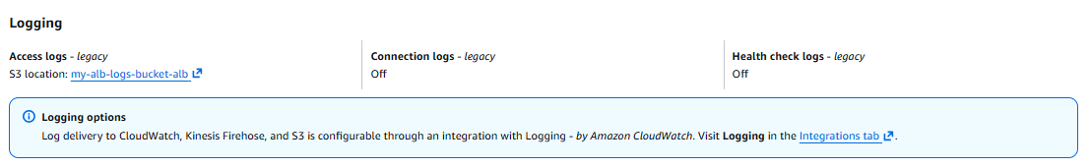

10. Store the VPC flow logs in a CloudWatch log group.

Objective :
To capture network traffic information from a VPC and send the VPC Flow Logs to a CloudWatch Log Group for monitoring, troubleshooting, and security analysis.

Traffic flow:
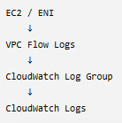

Prerequisites
- AWS Account
  - Active AWS account with required permissions.
- VPC
  - An existing VPC.
  - Preferably with EC2 instances/ENIs generating traffic.
- CloudWatch Log Group
  - Create a Log Group, for example:
/aws/vpc/flowlogs
- IAM Role
  - Create an IAM role that allows the VPC Flow Logs service to write logs to CloudWatch Logs.
  - The role needs permissions such as:
- logs:CreateLogGroup
- logs:CreateLogStream
logs:PutLogEvents
- IAM permissions for your user
  - You need permission to create/manage VPC Flow Logs and IAM roles.
- Region
  - VPC and CloudWatch Log Group should be configured in the appropriate AWS Region.

Step 1 : Create a CloudWatch Log Group
Go to:
AWS Console → CloudWatch → Log groups → Create log group
Enter:
Log group name:
/aws/vpc/flowlogs
Click Create.
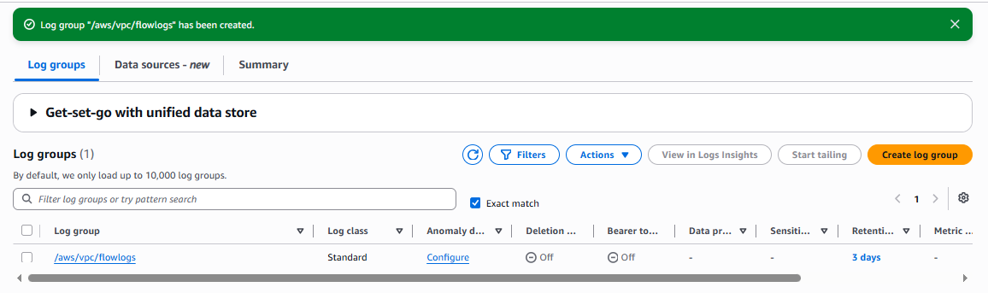

Step 2 : Create an IAM Role for VPC Flow Logs
Go to:
AWS Console → IAM → Roles → Create role

Select trusted entity
Choose:
AWS service
For service/use case, select:
VPC Flow Logs
Then click Next.
AWS will create/select the required permissions for publishing logs to CloudWatch Logs.
Give the role a name, for example:
VPCFlowLogsRole
Click Create role.
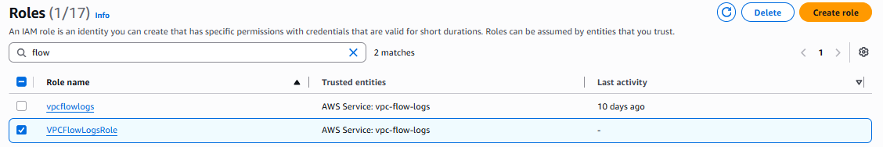

Step 3 : Go to your VPC
Go to:
AWS Console → VPC → Your VPCs
Select the VPC for which you want to capture traffic.
Then:
Actions → Create flow log

4. Configure Flow Log
You will see the Flow Log configuration.

Name
Production-VPC-FlowLogs

Filter
Choose:
All
This captures both:
ACCEPT
REJECT
You can also choose only REJECT if you only want denied traffic.

Maximum aggregation interval
Choose:
1 minute

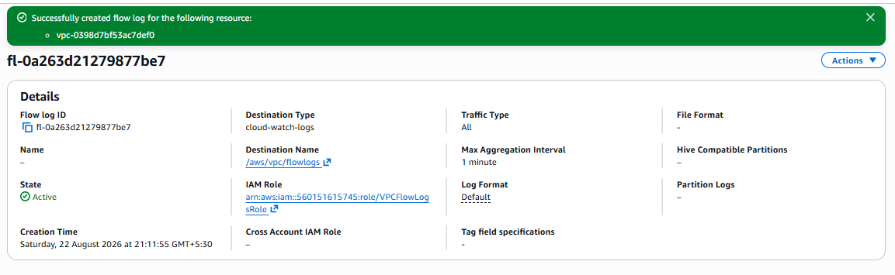

5. Select CloudWatch Logs
Under Destination select:
Send to CloudWatch Logs
For Destination log group, select:
/aws/vpc/flowlogs
For IAM role, select:
VPCFlowLogsRole

Step 6 : Create Flow Log
Click:
Create flow log
You should now see the flow log associated with your VPC.

Step 7 : Verify the logs
Go to:
CloudWatch → Log groups → /aws/vpc/flowlogs
Open the log group.
You should see a log stream.
Open the stream and you will see entries similar to:
2 123456789012 eni-0123456789abcdef0 10.0.1.10 10.0.2.20 443 52134 6 10 840 1755864000 1755864060 ACCEPT OK
These records provide information about network traffic such as:
Source IP
Destination IP
Source port
Destination port
Protocol
Packets
Bytes
Action

Step 8 : Understand the traffic flow
For example:
Client
|
v
EC2
10.0.1.10
|
| VPC Traffic
v
ENI
|
v
VPC Flow Logs
|
v
CloudWatch Log Group
/aws/vpc/flowlogs

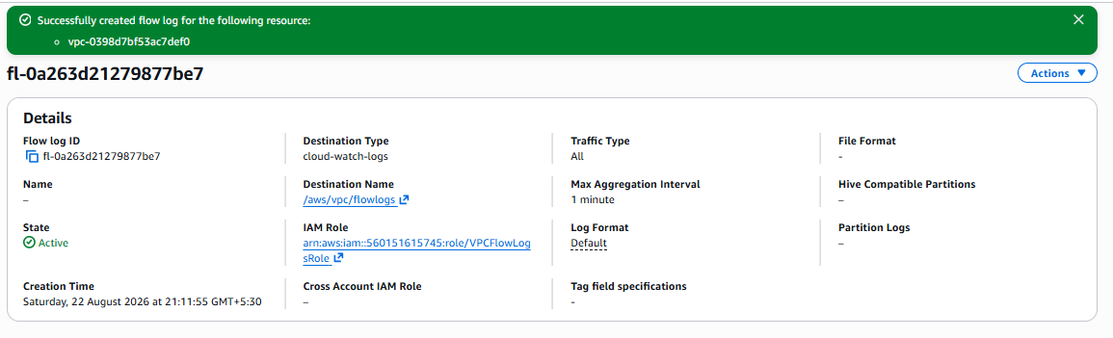

11. Create monitoring dashboards to monitor CPU utilization and to monitor the Apache service.

Objective :
The objective is to create an Amazon CloudWatch monitoring dashboard that allows us to monitor:
- EC2 CPU Utilization
- Apache (httpd) service status
- Detect whether Apache is running or stopped
- Identify server performance issues quickly
The dashboard gives a centralized view of the EC2 server's health.

Prerequisites :
Before starting, you need:
- An EC2 instance
- Apache installed on the EC2 instance
- Apache service running
- CloudWatch access
- IAM permissions to create/view CloudWatch dashboards
- For monitoring the Apache service itself, install and configure the CloudWatch Agent

Step 1 : Check Apache
On Amazon Linux/RHEL:
sudo systemctl status httpd
If it is not installed:
sudo dnf install httpd -y
Start it:
sudo systemctl start httpd
Enable it at boot:
sudo systemctl enable httpd
Verify:
sudo systemctl status httpd
You should see:
Active: active (running)
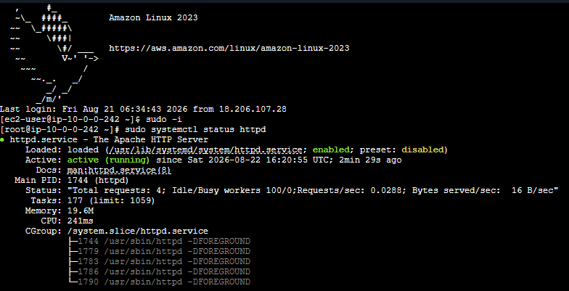

Step 3 :
There are two different things here:

CPU utilization
CloudWatch can monitor EC2 CPU utilization without installing an agent.
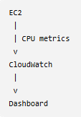
The metric is:
CPUUtilization

Apache service
CloudWatch does not automatically provide an Apache service-running metric.
We need the CloudWatch Agent to monitor the Apache process.
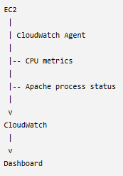

Step 4 : Create IAM Role for CloudWatch Agent
Go to:
AWS Console → IAM → Roles → Create role

Trusted entity
Select:
AWS service
Choose:
EC2
Click Next.

Add permission
Search for:
CloudWatchAgentServerPolicy
Select it.
Click Next.
Give the role a name:
CloudWatchAgentServerRole
Click:
Create role

Step 5 : Attach the Role to EC2
Go to:
EC2 → Instances
Select your EC2 instance.
Then:
Actions → Security → Modify IAM role
Select:
CloudWatchAgentServerRole
Click:
Update IAM role

Step 6 : Install CloudWatch Agent
Connect to your EC2 instance.
For Amazon Linux:
sudo dnf install amazon-cloudwatch-agent -y
Verify:
rpm -qa | grep amazon-cloudwatch-agent

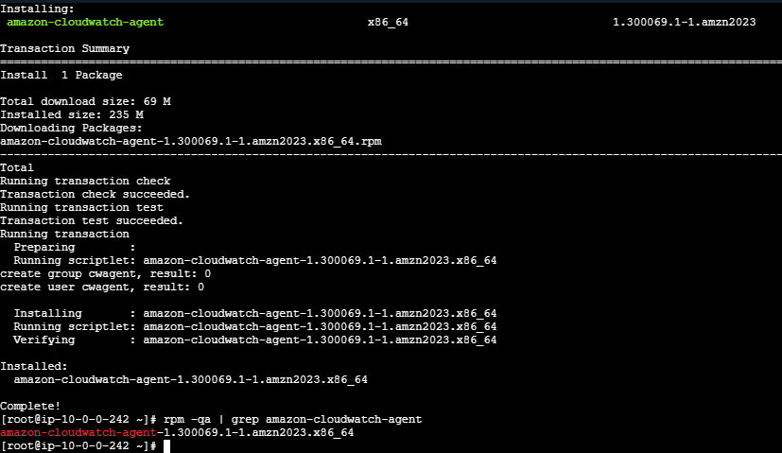

Step 7 : Configure CloudWatch Agent
You can use the configuration wizard:
sudo /opt/aws/amazon-cloudwatch-agent/bin/amazon-cloudwatch-agent-config-wizard
The wizard will ask several questions.
For a simple lab, configure:
Collect CPU metrics: Yes
Collect memory metrics: Yes
Collect disk metrics: Yes
Collect process metrics: Yes
For process monitoring, configure Apache/httpd.
The exact wizard questions can vary depending on the CloudWatch Agent version.

Step 8 : Start CloudWatch Agent
After configuration:
sudo /opt/aws/amazon-cloudwatch-agent/bin/amazon-cloudwatch-agent-ctl \
-a fetch-config \
-m ec2 \
-c file:/opt/aws/amazon-cloudwatch-agent/bin/config.json \
-s
Check the status:
sudo systemctl status amazon-cloudwatch-agent
You want:
Active: active (running)
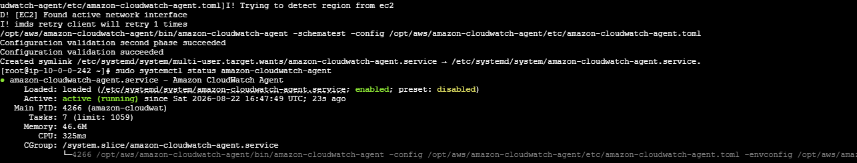

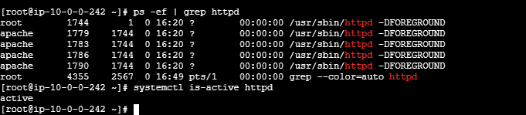

Step 10 : Create CloudWatch Dashboard
Go to:
AWS Console → CloudWatch → Dashboards
Click:
Create dashboard
Give it a name:
EC2-Apache-Monitoring
Click:
Create dashboard

Step 11 : Add CPU Utilization
Click:
Add widget
Select:
Line
Choose:
Metrics
Then:
EC2 → Per-Instance Metrics
Find:
CPUUtilization
Select your EC2 instance.
Click:
Create widget
You will now have a CPU graph.

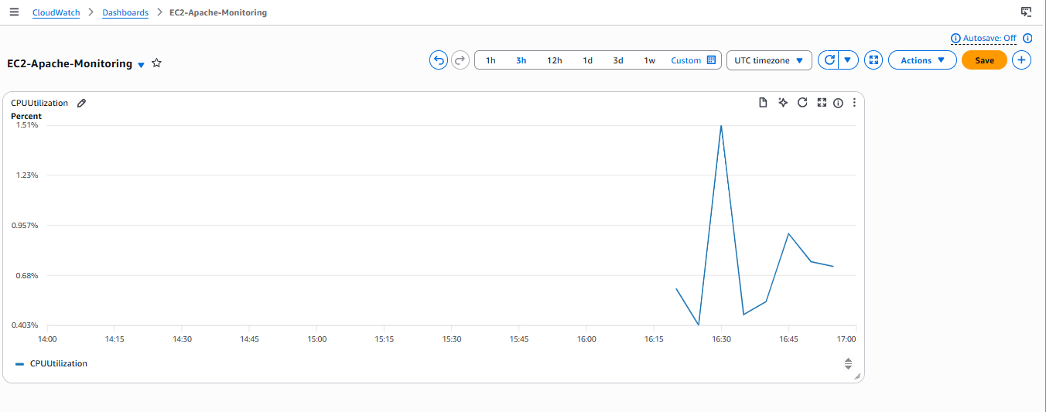

Step 12 : Add Apache Monitoring
The CloudWatch Agent can collect process-level information.
Depending on your agent configuration, you can monitor Apache/httpd process metrics such as:
procstat
For example:
procstat_lookup_pid_count
or other process-related metrics generated by the agent configuration.
In CloudWatch:
Metrics → CWAgent
Look for the metrics associated with your httpd/Apache process.
Add the relevant metric to your dashboard.

12. If CPU utilization is more than 70%, then it should trigger auto scaling and launch new instance.

Objective :
The objective is to configure an EC2 Auto Scaling Group (ASG) so that when the average CPU utilization of the instances goes above 70%, AWS automatically increases the number of EC2 instances by launching a new instance.
The architecture will be:
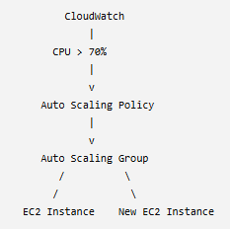

2. Prerequisites
You need:
- AWS account
- VPC
- At least 2 Availability Zones
- Public/private subnets as appropriate
- EC2 AMI containing your application/Apache
- Security Group
- IAM instance profile if your application requires AWS access
- Launch Template
- Auto Scaling Group
- CloudWatch
- A scaling policy
Task 12: Auto Scaling Based on CPU > 70%
Objective :
The objective is to configure AWS Auto Scaling so that when the EC2 instance CPU utilization goes above 70%, AWS automatically launches a new EC2 instance.
Workflow :
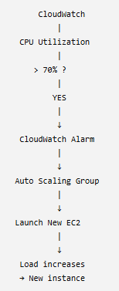

Prerequisites :
Before implementing this task, you should have:
- AWS Account
  - Active AWS account with permission to use EC2, CloudWatch and Auto Scaling.
- VPC
  - A VPC with at least one subnet.
  - Preferably two or more subnets in different Availability Zones for high availability.
- EC2 AMI
  - An AMI containing your required application/web server.
  - For example, an Amazon Linux EC2 instance with Apache or Nginx installed.
- Launch Template
  - Create an EC2 Launch Template containing:
    - AMI
    - Instance type
    - Security group
    - Key pair, if required
    - User data, if required
- Auto Scaling Group
  - Create an ASG using the Launch Template.
  - Example:
  - Minimum capacity = 1
  - Desired capacity = 1
Maximum capacity = 3
- CloudWatch
  - CloudWatch must monitor the EC2 CPU utilization.
  - EC2 provides basic CPU utilization metrics automatically; you don't normally need the CloudWatch Agent just for CPU utilization.
- IAM Permissions
  - Your AWS user/role needs appropriate permissions for:
    - EC2
    - Auto Scaling
    - CloudWatch
Step by step implementation :
1. Create an AMI from the configured Apache EC2 instance.
2. Create a Launch Template:
o AMI: Apache server AMI
o Instance Type: t2.micro
o Security Group: Web Server Security Group

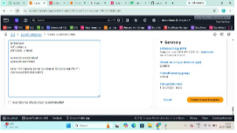

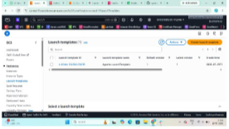

3. Create an Auto Scaling Group:
o VPC: Project-VPC
o Subnets: Public-Subnet and Private-Subnet (or the desired application subnets)
o Attach the existing Application Load Balancer target group.
4. Set:
o Desired Capacity: 2
o Minimum Capacity: 2
o Maximum Capacity: 4
5. Add a target tracking scaling policy:
o Metric: Average CPU Utilization
o Target Value: 70%
6. Create the Auto Scaling Group.
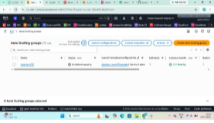
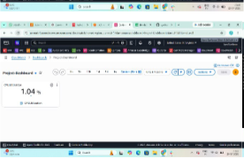
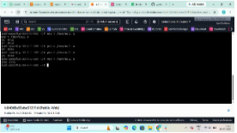

AWS will automatically launch additional EC2 instances when the average CPU utilization exceeds
70% and terminate extra instances when the load decreases.

